Research Security Training (Combined Course)
This will walk you through completing the Research Security Training required by the Department of Energy, National Science Foundation and National Institutes of Health in accordance with Section 10634 of the CHIPS and Science Act of 2022 (42 U.S.C. § 19234). For most individuals, the condensed Combined Course is sufficient.
There is a full 4-module, 4-hour training (Long Course) available at https://www.nsf.gov/research-security/training.
Alternatively, a condensed 1-hour training (Combined Course) is available, which this guide will cover.
Step 1: Navigate to CITI
Step 2: Click ‘Log In’ at the top right of the page.
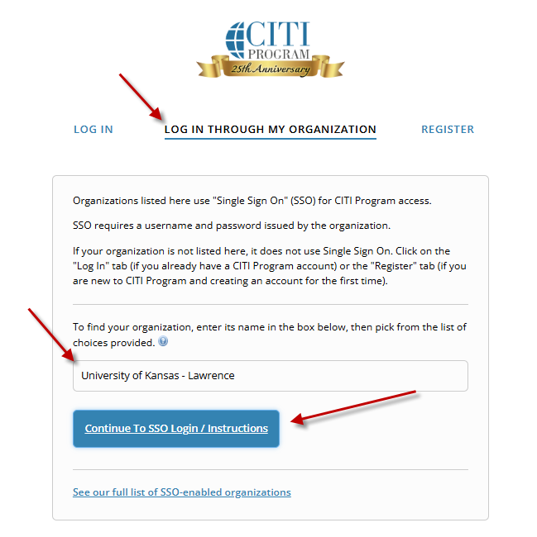
Step 3: Click ‘LOG IN THROUGH MY ORGANIZATION’ above the Username field.
- Type “University of Kansas” and select ‘University of Kansas – Lawrence’.
- Click ‘Continue to SSO Login / Instructions’
- Log in with your KU credentials.
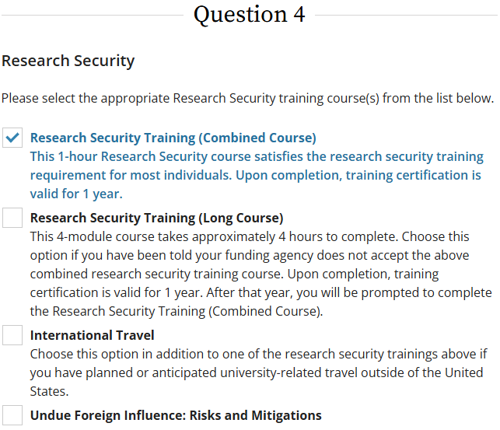
Step 4a: If you already have a CITI Program account, then log in with your CITI Program Username and Password.
- Scroll down and click ‘Add a Course’ then skip to Step 5.
Step 4b: If you don’t have a CITI Program account, then click ‘Create A New CITI Program Account’ and complete the requested information.
Step 5: Scroll down to Question 4 > Research Security Training (Combined Course) and check the box.
- Scroll down and click ‘Submit’ and proceed to Step 6.

Step 6: Click ‘Start Now’ in the Research Security Training (Combined Course) section to complete the module.
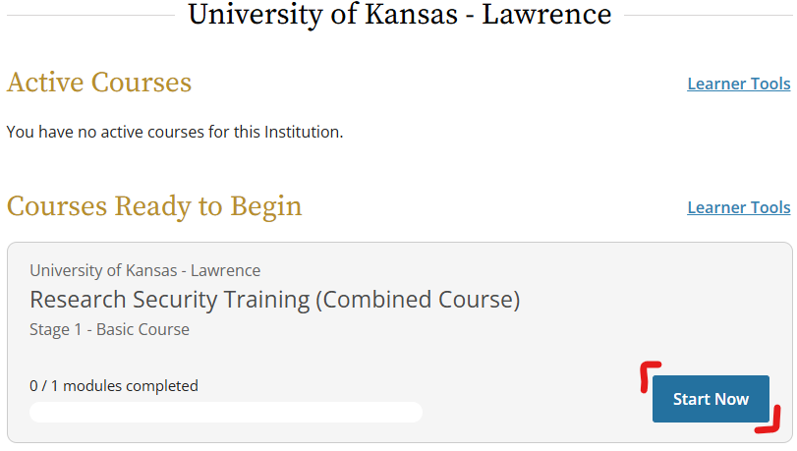
Step 7: The Research Security Training should appear under your Completed Courses records.
- This training is valid for one year.
- Provide a copy of your certificate to the Pre-Award staff member assisting you with your grant application.

